Analogue and digital data

Analogue

Analogue data is physical like anything you hear and say and some examples of analogue is human voices, temperature and musical instruments. Also analogue travels in waves which look like this.

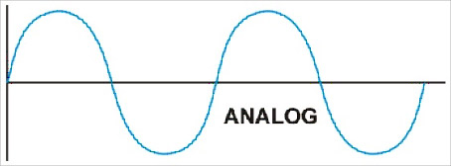

And the conversion is when the analogue is transferred in to a mice phone then the computer samples the data by fulling the caps between the wave to make it look more like a digital data wave. And he conversion looks like this

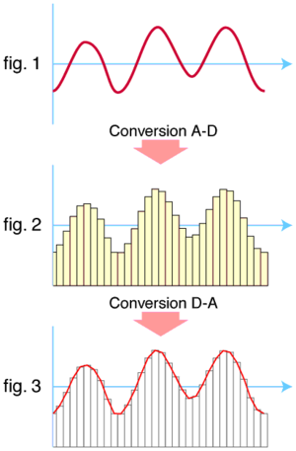

Digital data

Digital data is a digital sound and the digital is stored in bits and bytes and the sound in up and down on the digital. Also digital data travels in waves which look like this.

